# **FINAL PROJECT PROGRESS**

**Title:** Live twitter data analysis using Cloud services

**Team members:**

1. Dhanunjaya Lakshman, Koneru (Student ID: 16336828)
2. Lakshmi Durga Likhitha, Tellakula (Student ID: 16335481)
3. Sushmitha Reddy, Pollapalli (Student ID: 16336844)
4. Siddartha Rao, Damarla (Student ID: 16337125)

**Roles and Responsibilities:**

* Lakshman and Likhitha are responsible for research, pre-processing, transforming, and visualizing the data. Checking the compatibility of tools used and preprocessing the data in Lambda using Pandas, handling CloudWatch and hosting interactive dashboards using EBS are the typical tasks handled by them.
* Sushmitha and Siddhartha are responsible for installing libraries using EC2, extracting tweets from twitter, producing visualizations using Plotly and storing the results in S3 are the typical tasks handled by them.

**Present Progress:**

1. Created an S3 bucket for the storage of results in objects and made it public.

1. Installed all the libraries required for the project.

1. Created the Lambda Layer where we uploaded the packages as a zip folder so to use in the functions with the compatible runtime as Python 3.9 version.

1. Created a Lambda Function **cars.**

1. Added the above created layer to the cars function.

1. Created access key to access the AWS services programmatically.

1. Created the twitter developer account and got the bearer token and connected the account with the tweepy package.

1. Created the session using the boto3 and the created access keys.

1. Got the twitter IDs of the car companies through the twitter developer account created.

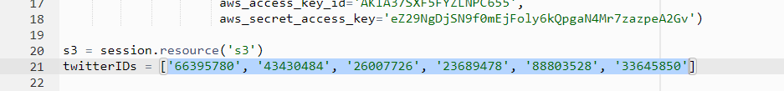

1. We wrote the lambda_handler function in which data is extracted from the car companies twitter accounts and activity of each company in the last 6 months. This data is presented visually in the bar charts where the data is stored in the S3 object, and the object is made publicly available. This whole process is automated and written in the lambda_handler.

1. Creation of objects and updating them is automated.

1. While testing the code we faced some errors where we rectified the errors and made it successful.

1. As mentioned the objects are created in the bucket where result is stored in JSON format and visualization in html file where it can be viewed.

1. Storing the data visualization in the html object and making it publicly accessible URL.

